In-Depth Research Report on Business Logic Bugs

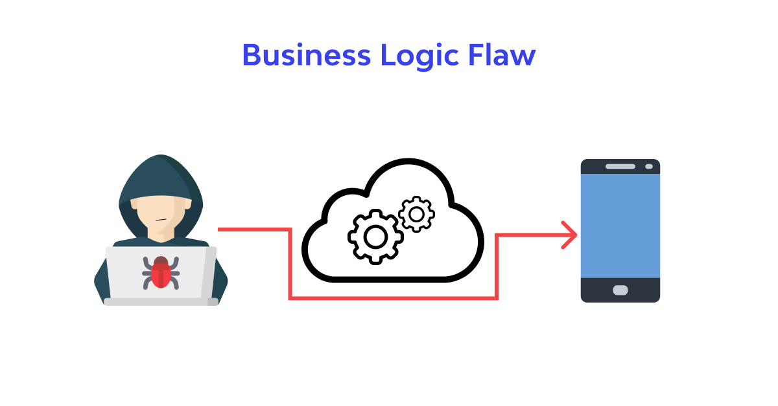

1. Introduction

Definition of Business Logic Bugs
Business logic bugs are vulnerabilities that arise from flaws in the underlying logic of an application or system, which can lead to unintended behavior. Unlike traditional software bugs, which might cause a program to crash or behave unexpectedly, business logic bugs directly impact the functionality and correctness of business processes.

Importance of Addressing Business Logic Bugs
Addressing these vulnerabilities is crucial because they can lead to significant security risks, financial losses, and damage to the organization's reputation. They often exploit the intended functionality of the application rather than bypassing it entirely.

2. Types of Business Logic Bugs

2.1 Validation Errors
These occur when an application fails to validate user inputs correctly, allowing for inappropriate data manipulation.

2.2 Authorization Issues
Authorization bugs arise when users can perform actions or access data beyond their permissions, often due to inadequate checks in the logic.

2.3 Workflow Flaws
These bugs occur when business processes are not followed correctly, allowing for deviations that could lead to fraud or misuse.

2.4 Race Conditions
Race conditions happen when multiple processes access and modify shared data concurrently, leading to unexpected results.

2.5 Misconfigurations
Incorrect configurations can lead to vulnerabilities where security measures are not appropriately applied, allowing exploitation.

2.6 Insufficient Input Validation
This involves inadequate checks on user input, which can result in malicious data being processed.

2.7 Improper Error Handling
Flaws in error handling can expose sensitive information or allow attackers to deduce system behavior.

3. Impact of Business Logic Bugs

3.1 Financial Impact
Business logic bugs can lead to financial losses through fraud, billing errors, and exploitation of pricing models.

3.2 Reputational Damage
Organizations that experience data breaches or misuse due to business logic flaws may suffer long-lasting reputational damage.

3.3 Regulatory Consequences
Compliance violations can arise from business logic bugs, leading to legal repercussions and fines.

3.4 User Experience Degradation
Users may face frustration and a lack of trust in systems that exhibit inconsistent or incorrect behavior due to these bugs.

4. Mitigation Measures

4.1 Code Reviews and Audits
Regular code reviews and audits can help identify potential business logic vulnerabilities before they are exploited.

4.2 Automated Testing
Implementing automated testing frameworks can ensure that business logic is validated against expected outcomes.

4.3 User Behavior Monitoring
Monitoring user interactions can help detect unusual patterns that may indicate exploitation of business logic flaws.

4.4 Employee Training
Training employees on secure coding practices and the implications of business logic vulnerabilities can reduce risks.

4.5 Security Frameworks and Best Practices
Employing established security frameworks and adhering to industry best practices can provide guidance in designing robust business logic.

5. Conclusion

Summary of Key Points
Business logic bugs pose significant risks to organizations and can result in severe consequences if left unaddressed. Understanding the types of bugs, their impacts, and implementing effective mitigation strategies are critical for any business reliant on software systems.

Future Directions in Business Logic Bug Management
As technology evolves, so do the strategies employed by attackers. Continuous improvement in security measures, adoption of advanced testing methodologies, and ongoing education will be essential in combating business logic vulnerabilities.

6. References
- OWASP. (2023). OWASP Top Ten - 2023. OWASP Website
- Gupta, A. (2022). Understanding Business Logic Vulnerabilities. International Journal of Computer Applications, 182(5), 15-21.
- McGraw, G. (2006). Software Security: Building Security In. Addison-Wesley.
- SANS Institute. (2021). The Risks of Business Logic Flaws. SANS Website
- Cigital. (2017). Business Logic Vulnerabilities: The New Attack Surface. Cigital Whitepaper

